Schools compete in Lego robotics bout

February 8, 2016

[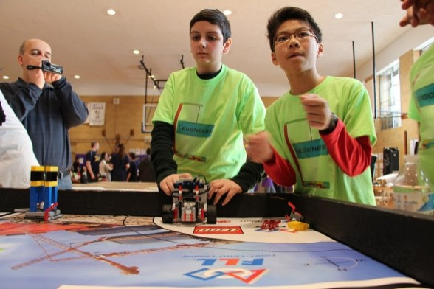](http://www.timesledger.com/assets/photos/2016/5/legorobot_2016_02_05_q01_z.jpg)

Photo by Sadef Kully

According to First NYC regional planning committee, an estimated 50 percent of the schools in each borough advance onto the regional robotics tournament in March at the Jabob Javits center.

**By Sadef Ali Kully**

More than 30 schools across the borough competed Sunday in the First Lego League, a competition at George Ryan Junior High School in Flushing, to qualify for the annual NYC Regional First robotics contest in March.

Hundreds of students and parents gathered around tables to watch colorful Lego robots sort trash and recycle material.

Student robotics teams have to design the robot, create the program for the robot and then build the robot that will compete in the regional competition.

“I am so proud of my daughter,” Wei Fu, whose child’s team from PS 119 in Glendale advanced to the regional competition.

First (For Inspiration and Recognition of Science and Technology), a non-profit, was founded in 1989 to encourage students to pursue education and careers in Stem-related fields.

“Queens has a lot of Stem schools, so the competition can become really interesting and you really get to see student ideas come to life,” said Richard Wong, who sits on the First planning committee for the New York City regional competition, said.

Wong said the theme of the competition this year is trash technology.

“It’s innovative ways to deal with trash using technology,” he said.

“Our students visited a local recycling plant and spoke with the owner about some of the problems he has had with his machines,” said Eric Greene, teacher and robotics team leader at PS 192 in College Point.

Greene said the owner told them the machines were having a difficult time recycling items based on the barcode. Each machine reads a barcode on recyclable material and then sorts it. His team came up with an idea to use color coding in addition to the barcode so it is easier for machines to identify and sort the recyclable materials.

“The teams that win these rounds in each borough go on to the final tri-state area tournament,” Wong said. “We judge on the robot design, why they chose the design and why they designed it that way. We try to give them awards for different successes throughout the competition.”

Wong said that in addition to advancing in the competition, students must also present their ideas to the judges.

“It teaches them critical thinking. They are required to think on their feet, it teaches them ownership and resiliency. You struggle and then you might fail. It is real-life work situations,” said Greene.

According to Wong, an estimated 50 percent of the schools in each borough qualify to go on to the annual NYC Regional First competition held at the Jacob Javits Center in March. The winner of the NYC Regional will compete in the international contest held in St. Louis, Mo., in the fall.

*Reach Reporter Sadef Ali Kully by e-mail at*[*skully@cnglocal.com*](mailto:skully@cnglocal.com)*or by phone at (718) 260–4546.*